If you are having trouble or cannot find the pages you are looking for it might be due an incorrect saved zip code. Here’s how to fix it and register.
(less than 3 minutes)

1) First go to the bottom of any page on this site

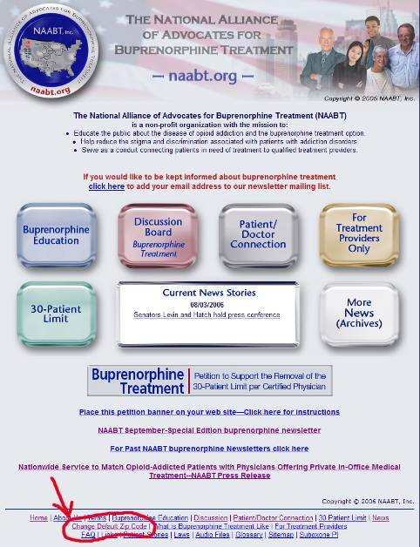

2) Click on “Change Default Zip” at the bottom of all pages at naabt.org

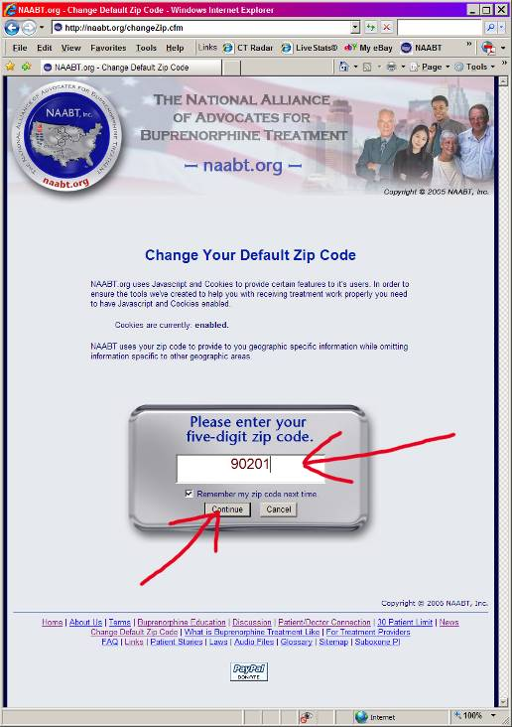

3) When prompted enter accurate zip and click continue. If your zip is not accepted pick another one near you.

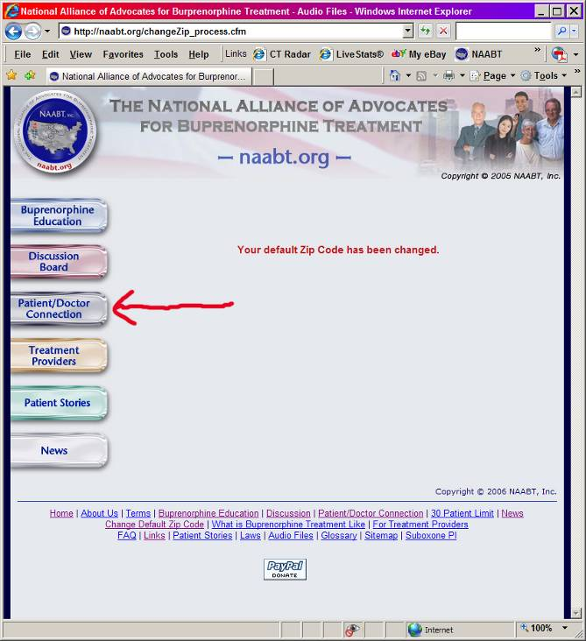

4) Then you will have access to the patient physician matching system function of the site. Click Patient / Doctor connection to see.

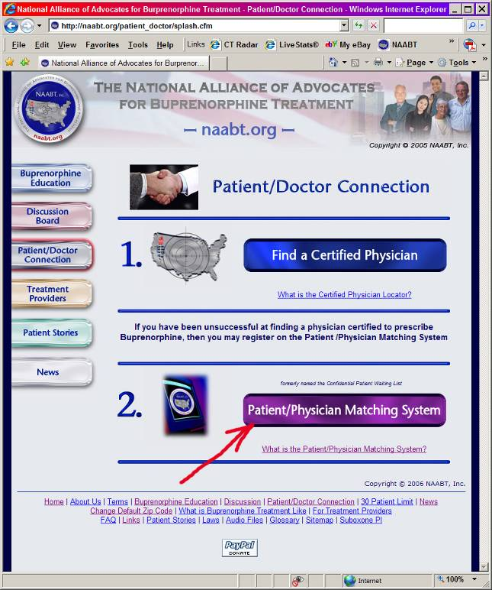

5) You now have a choice to search for doctors or go to the Matching system, choose Matching system.

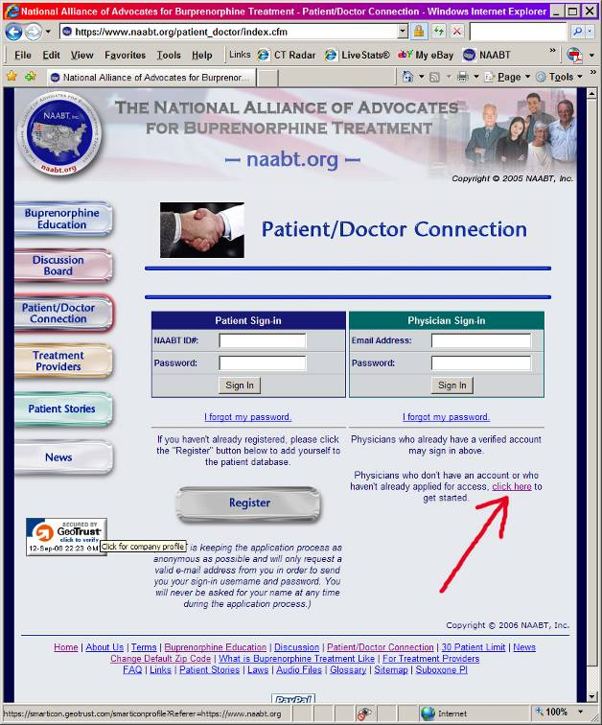

6) For physicians to register click on “Click here”

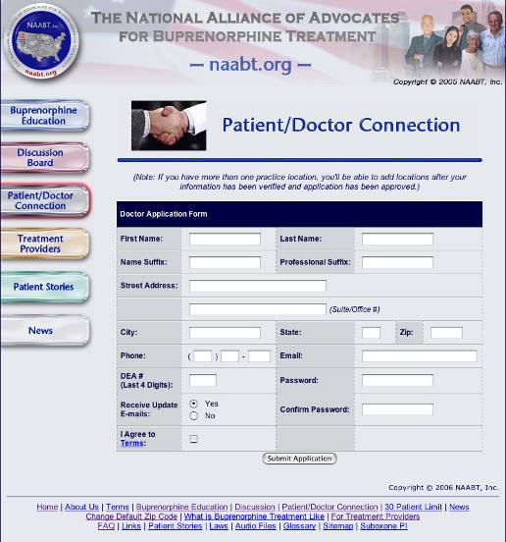

7) The just fill out the application click submit and you will receive a confirmation email with instructions on how to use it.

Please email MakeContact@naabt.org for more answers to questions

Many of the files on this site, including the instruction brochures, require a PDF reader. This is a standard file format and most newer computers will be able to open these files. If you cannot, the reader can be downloaded for free at: http://www.adobe.com/products/acrobat/readstep2.html

